Admin Documentation
- Login Page:
URL: https://projects.goigi.biz/411web3/admin/

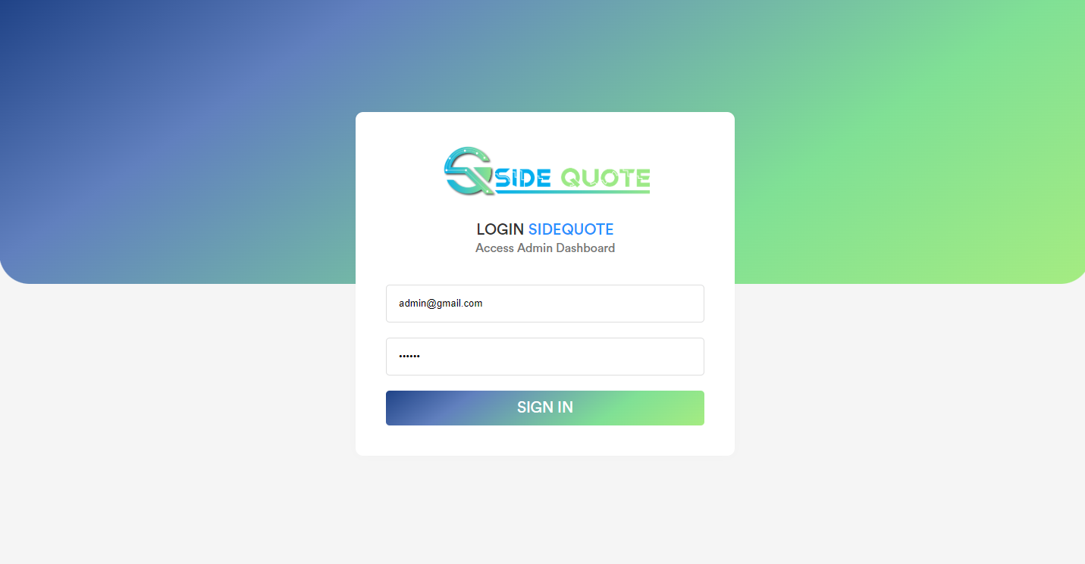

- Dashboard:
After login into the admin panel user will be redirect to the dashboard page.

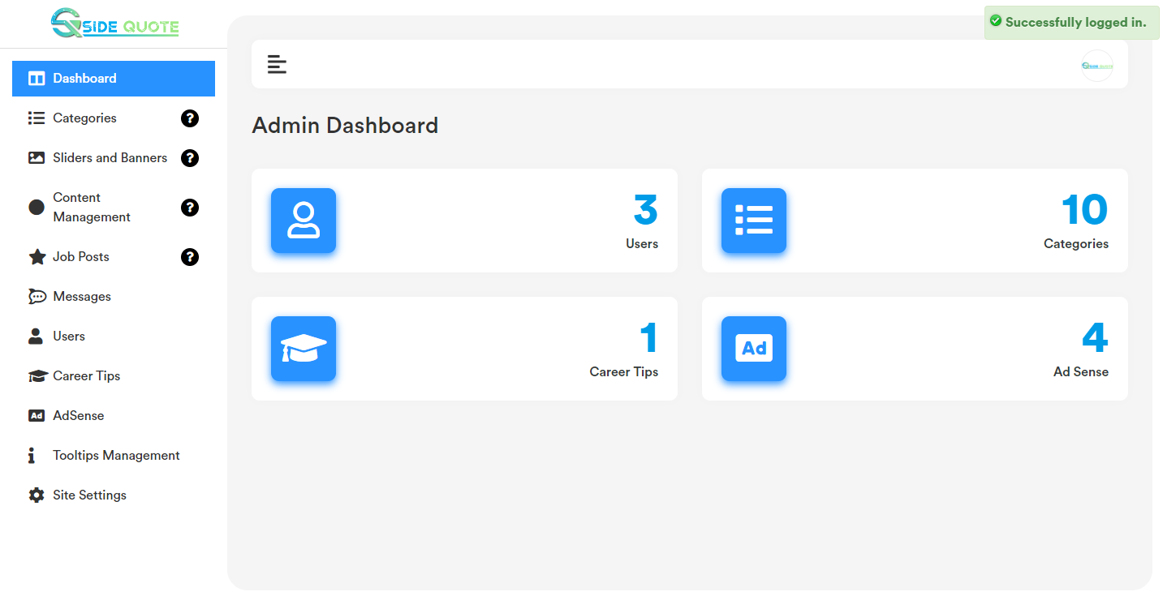

- Category:
Category added by admin will show in the website frontend, when user try to add post.
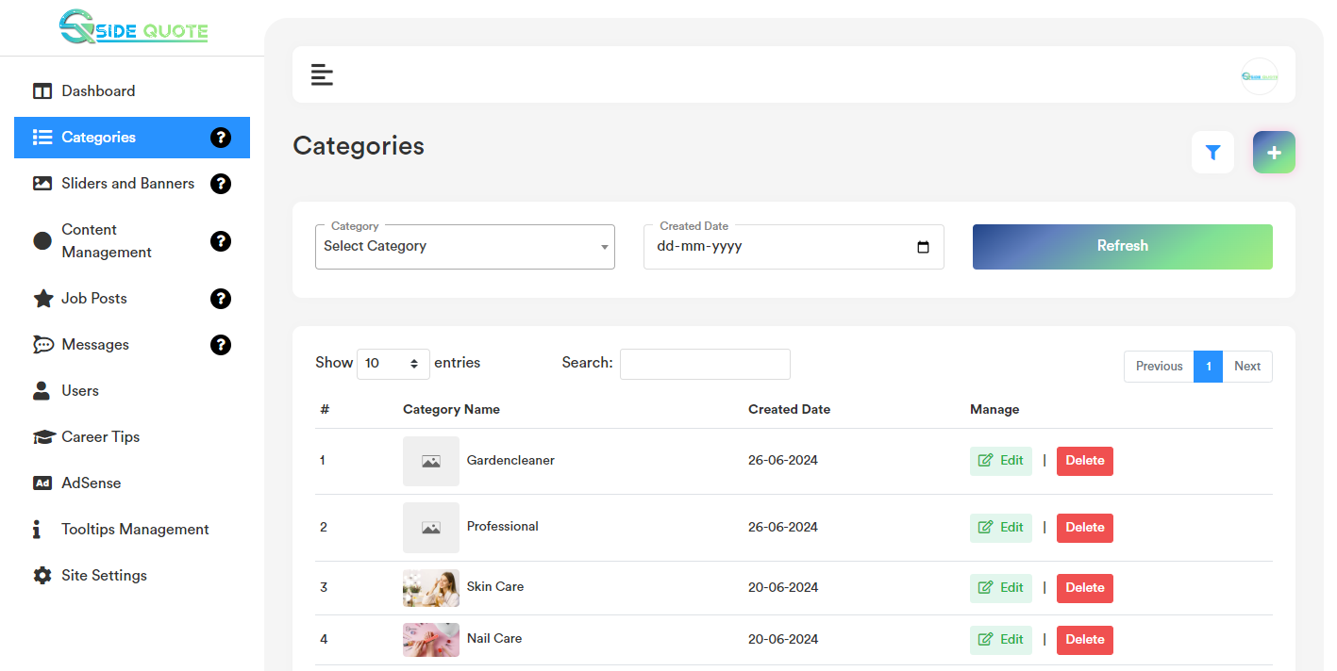

- Add Category:
Category list page top right corner click on the “+” icon. User will get a form to add new category. Please check the below screenshot.

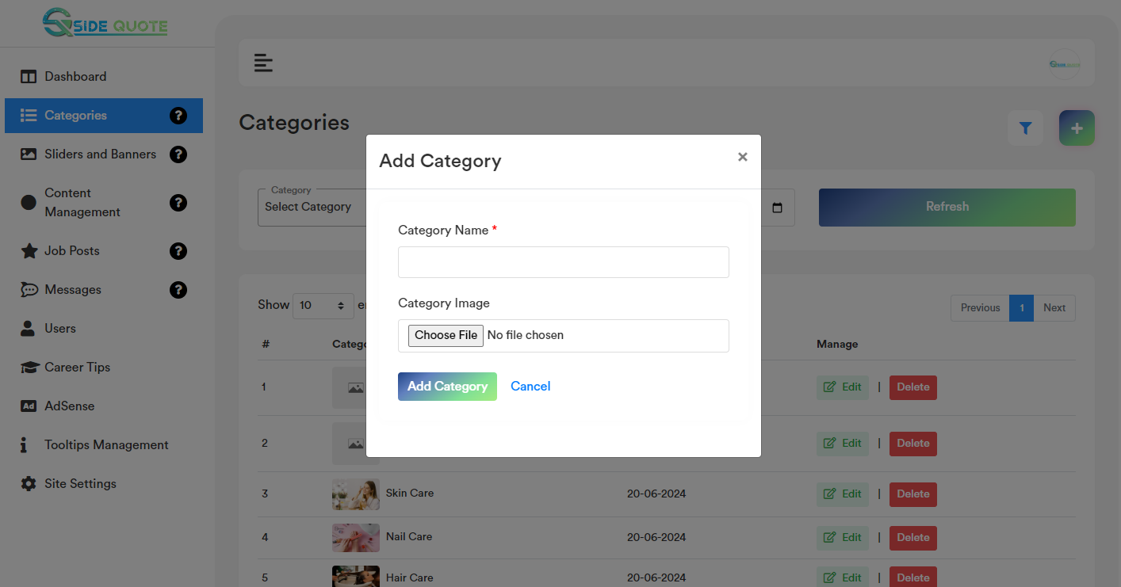

b. Edit Category:
Category list page for each record if user click on the “Edit” option, it will open a form containing the existing category data for that particular record. After making the change click on the “Save Changes” button. It will update the existing record with the updated data. Please check the below screenshot.

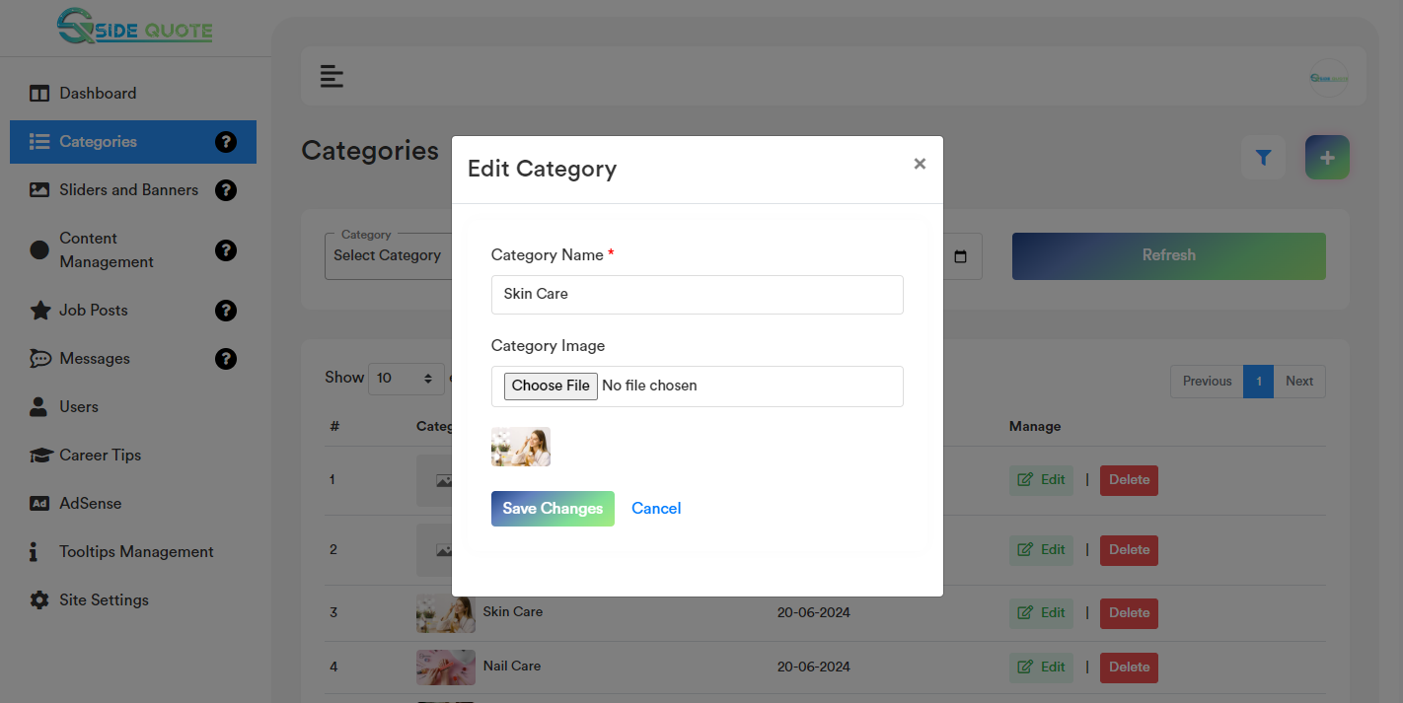
- Delete Record:
If user click on the “Delete” Button, user will get a confirmation popup. Once confirm it will delete the related category data. If any job post is there related to any category and admin wants to delete that category, it will show an alert “Job post is there related to this category. Please delete the job first to delete this category”. After delete the post job user will only be able to delete the category.
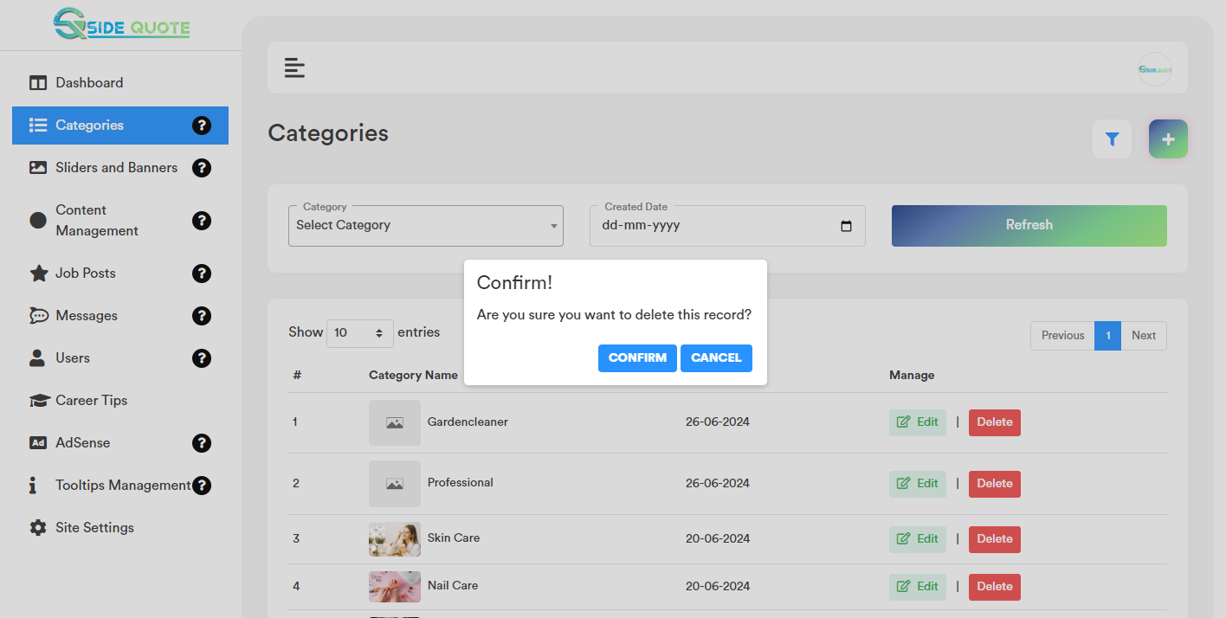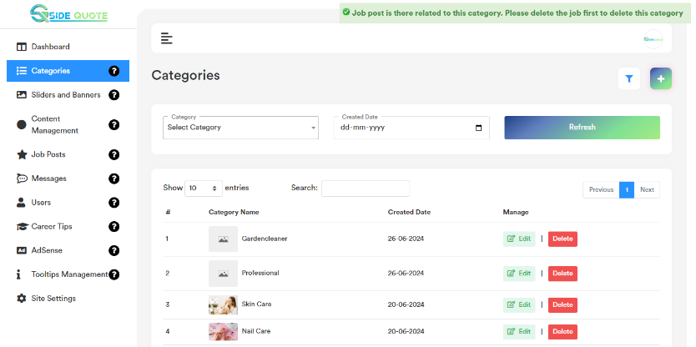
- Category Filter: Based on the added category and created date admin will be able to filter any category from the category list.
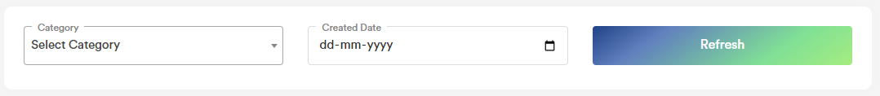

- Category Search: User can search any record by typing text on the search textbox.

- Sliders and Banners:
All the listed banner will show in the respective frontend pages.

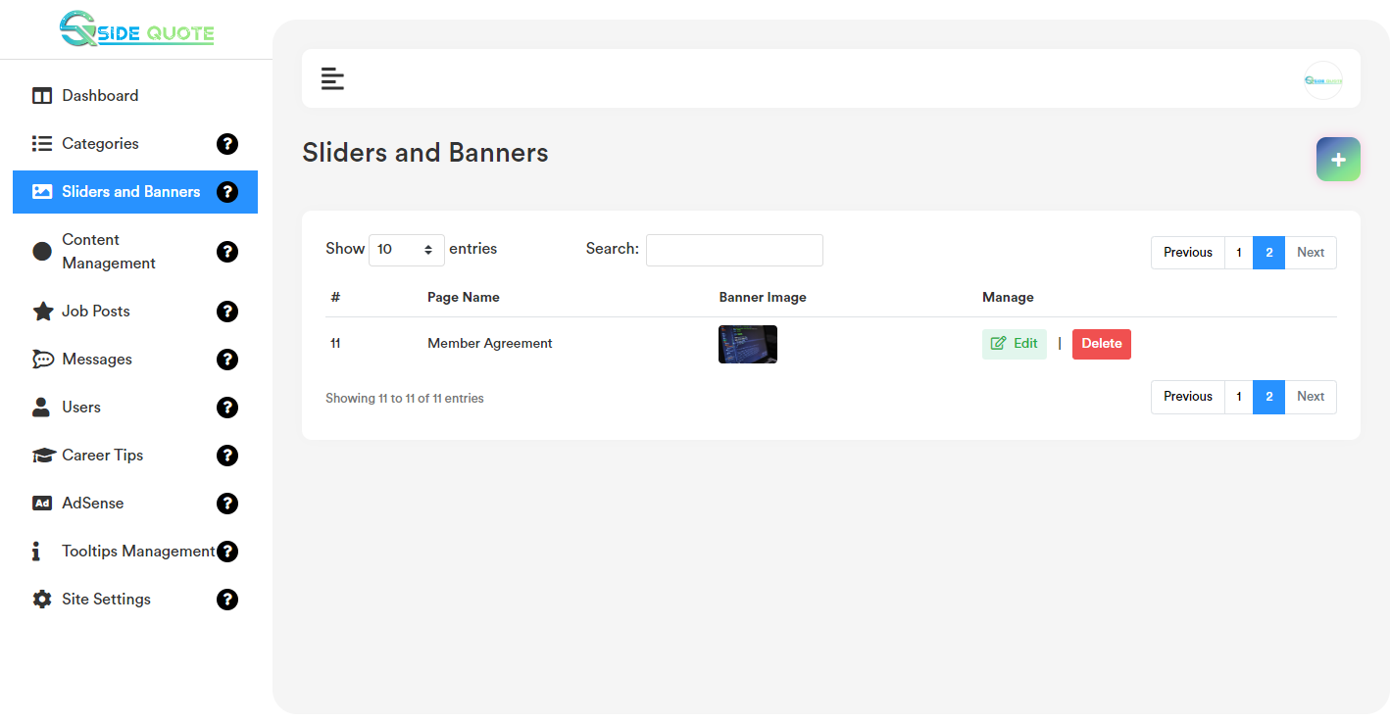

- Add Sliders and Banners:
Sliders and Banners list page top right corner click on the “+” icon. User will get a form to add new banner. Please check the below screenshot.
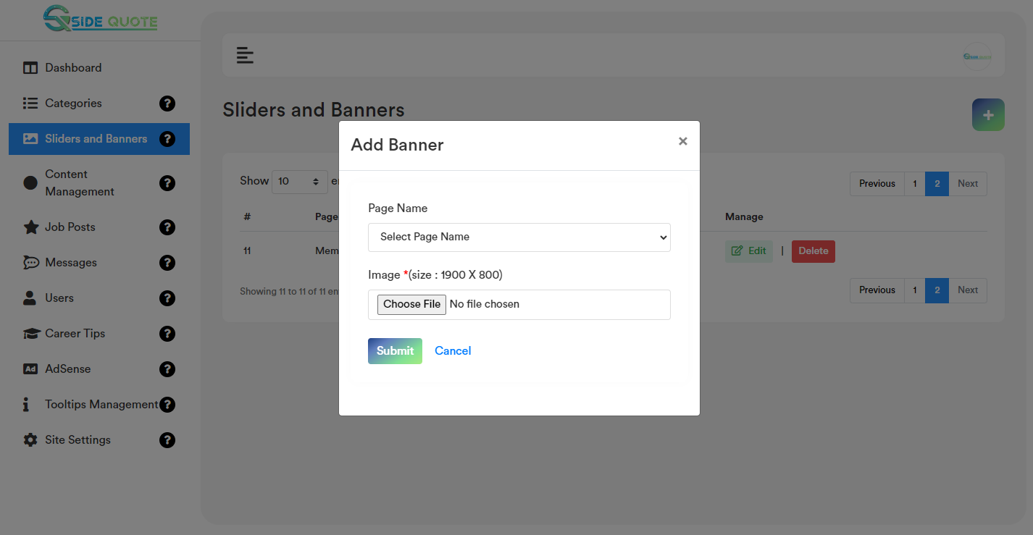

- Edit Sliders and Banners:
Banner list page for each record if user click on the “Edit” option, it will open a form containing the existing banner data for that particular record. After making the change click on the “Save Changes” button. It will update the existing record will the updated data. Please check the below screenshot.
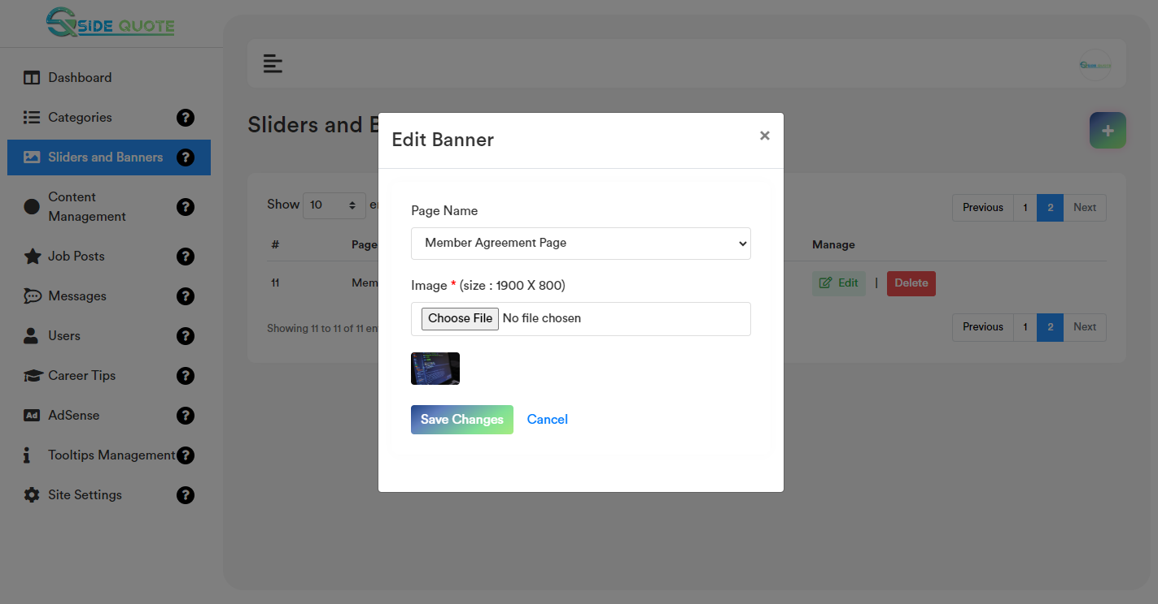

- Delete Sliders and Banners:
If user click on the “Delete” Button, user will get a confirmation popup. Once confirm it will delete the related banner data.

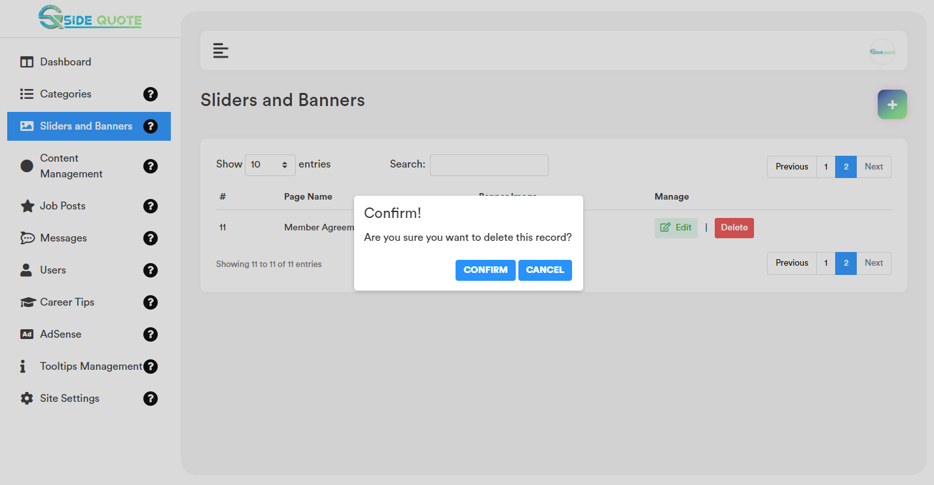

- Sliders and Banners Search:
User can search any record by typing text on the search textbox.

- Content Management:
Admin will be able to update or change ‘About Us’, ‘Privacy Policy’, ‘Terms and Conditions’, ‘Cookie Policy’, ‘Member Agreement’ page content.
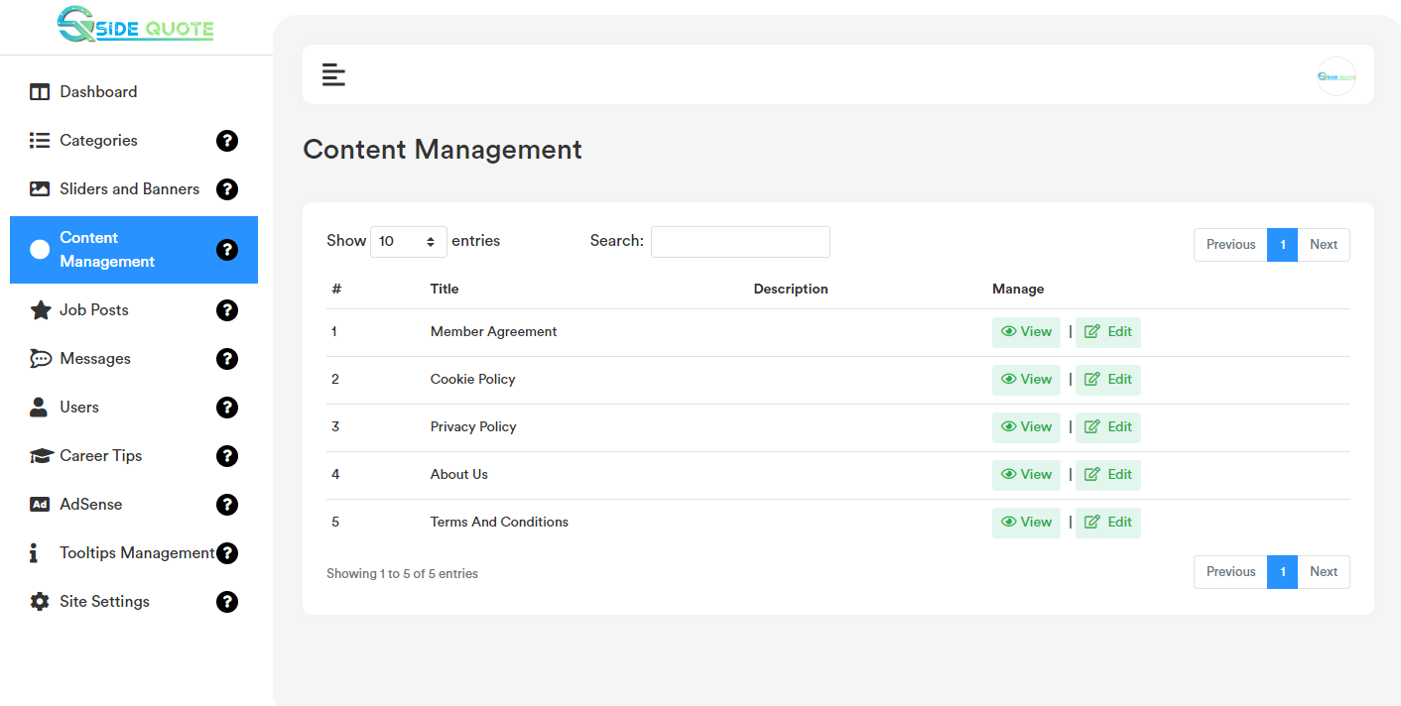

- Edit Content Management:
Content Management list page for each record if user click on the “Edit” option, it will open a form containing the existing data for that particular record. After making the change click on the “Save Changes” button. It will update the existing record will the updated data. Please check the below screenshot.
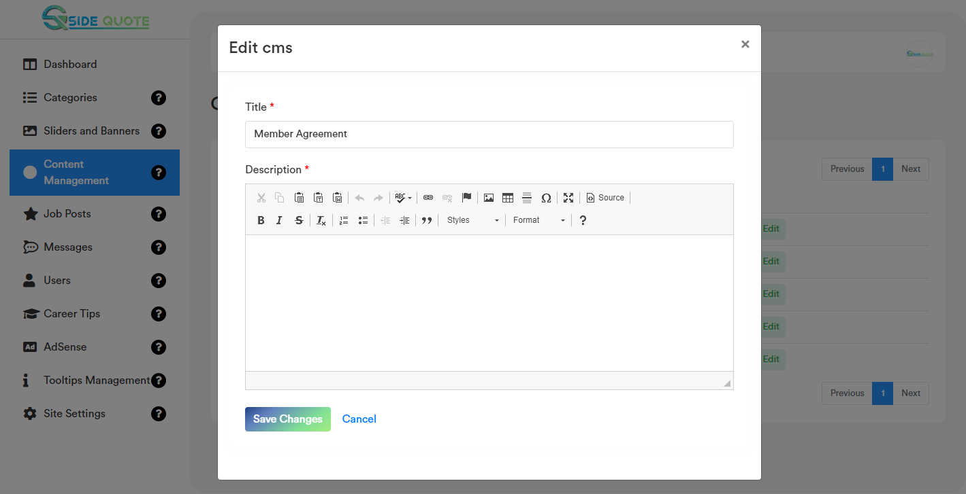

- View Content Management:
Content Management list page for each record if user click on the “View” button option, it will open a modal containing the data for that particular record. Please check the below screenshot.

- Content Management Search:
User can search any record by typing text on the search textbox.

- Job Posts Section:
All job posted by users will listed in the job post section. Admin can edit, update, delete and also change the status of a particular job.
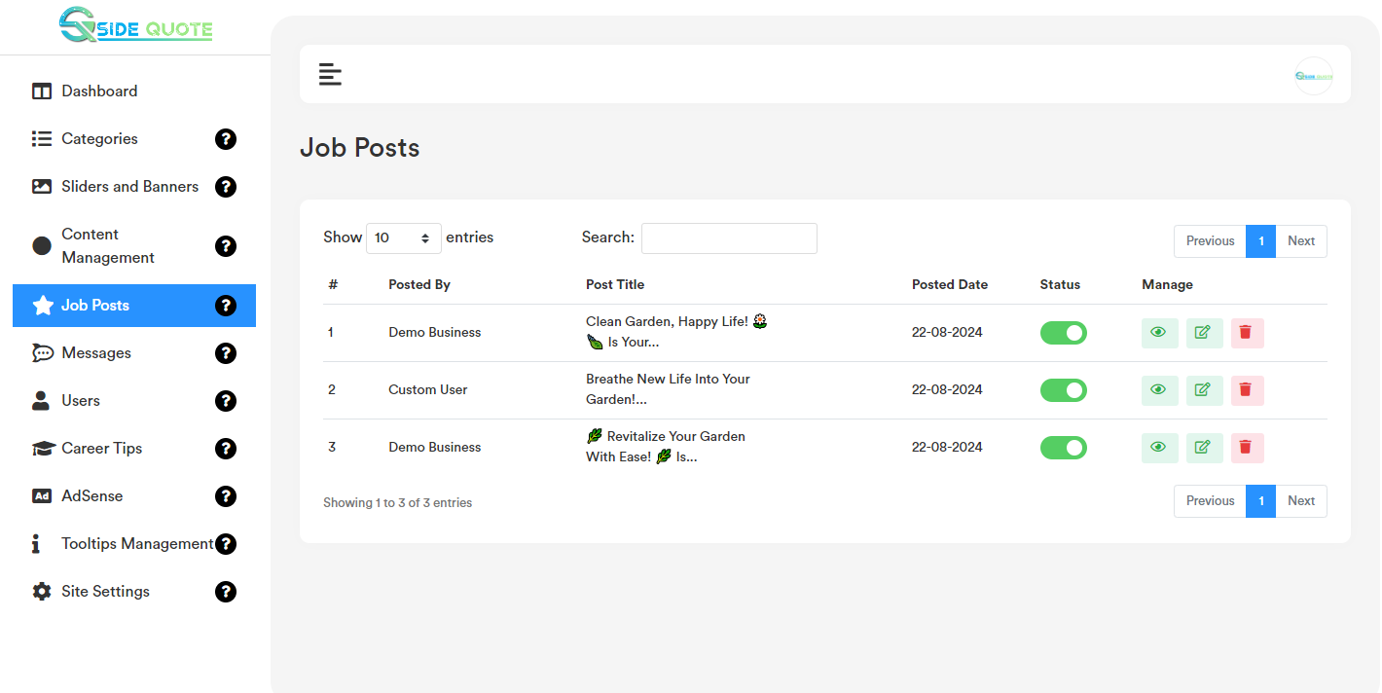

- View Job Posts:
Job Post list page for each record if user click on the “View” option, it will redirect to the frontend post job details page. Please check the below screenshot.
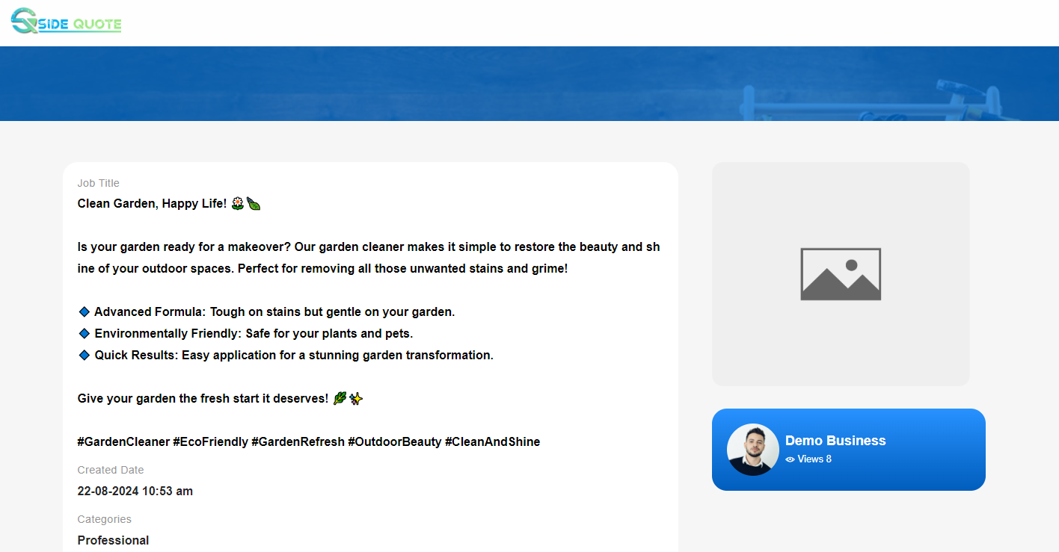
- Delete Job Posts:
If user click on the “Delete” Button, user will get a confirmation popup. Once confirm it will delete the related banner data.

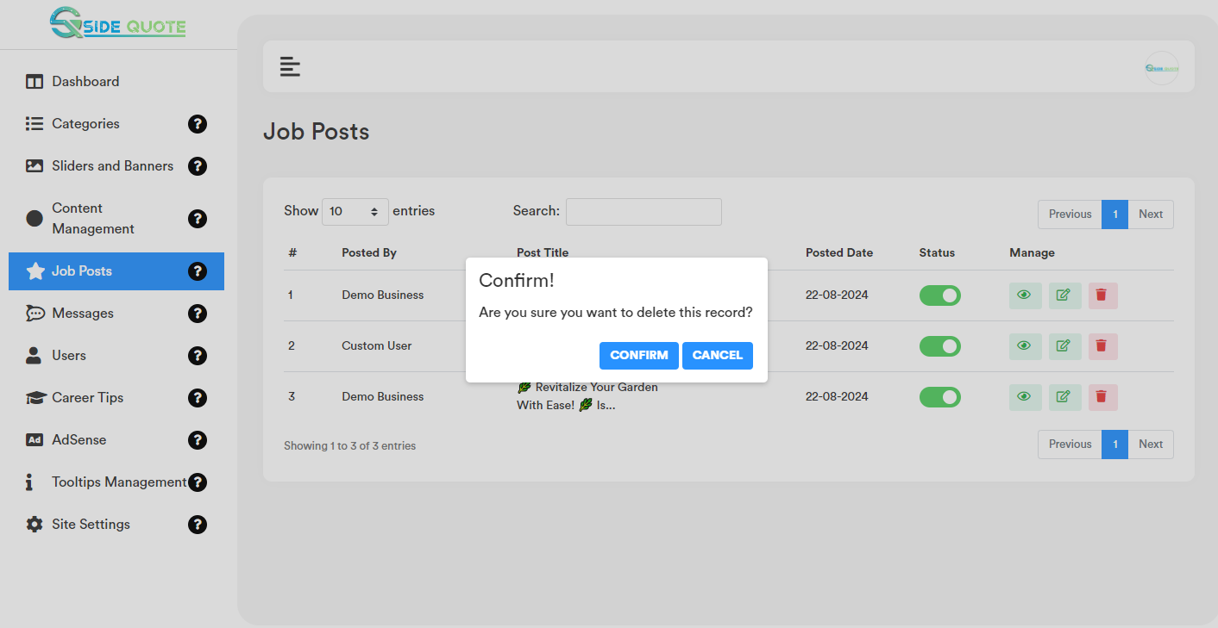

- Job Posts (Active/Inactive):
Once user click on the toggle button user will get a confirmation popup to active/inactive the job posts.

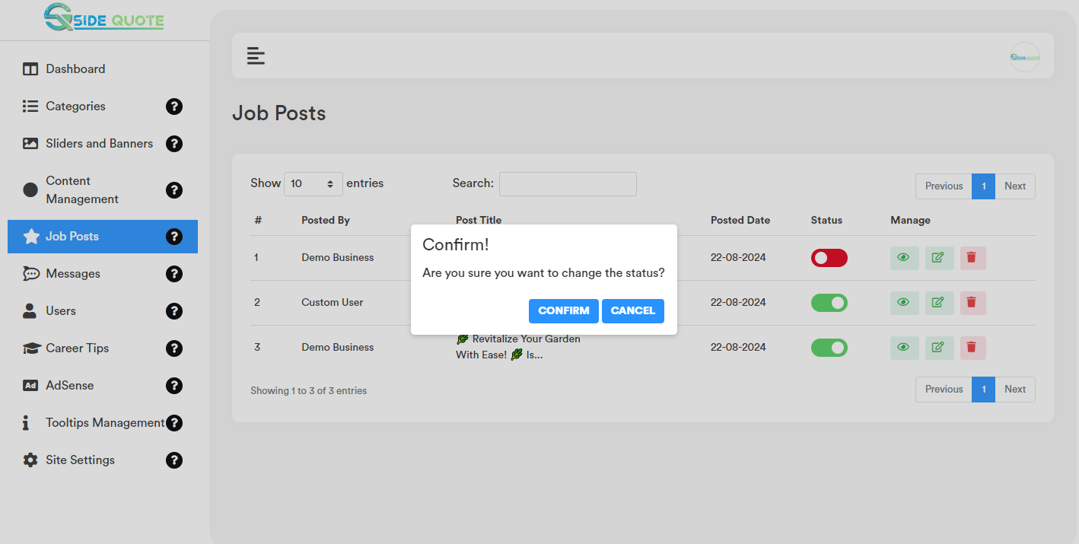

- Content Job Posts:
User can search any record by typing text on the search textbox.

- Users:
All the registered users will be listed in the uses section. Admin can verify user, change status, update users details and delete users.
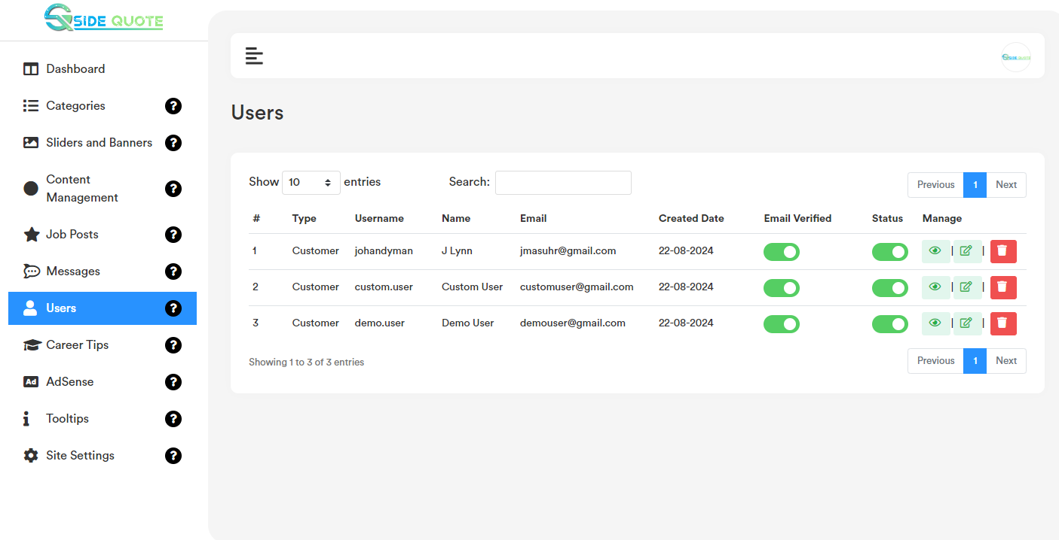

- View Users:
Users list page top right corner click on the “Eye Icon” icon, it will redirect to the particular users details page in the website frontend. Please check the below screenshot.
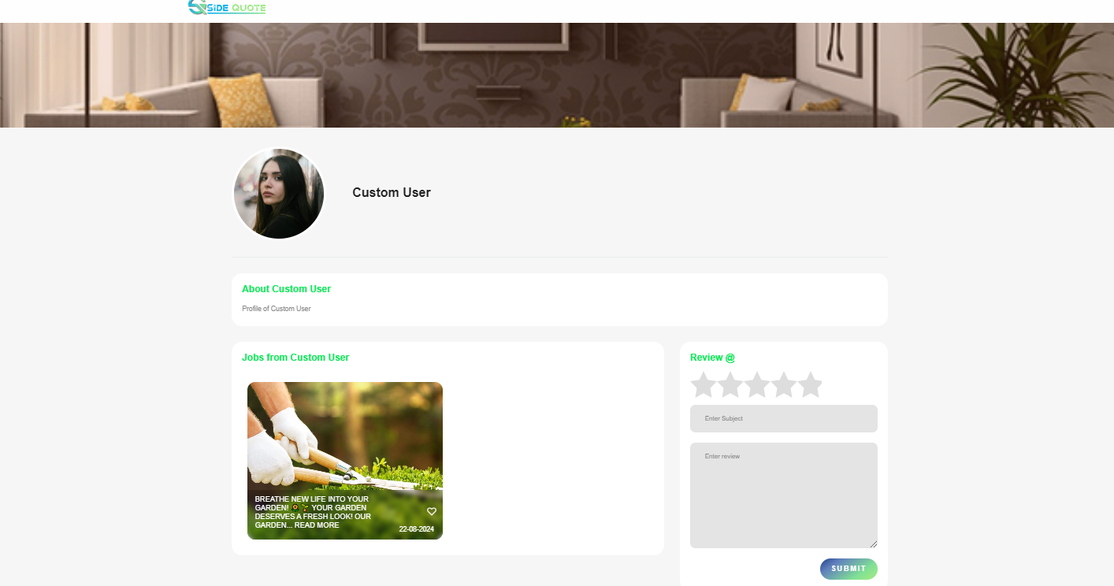
b. Edit Users:
Users list page for each record if user click on the “Edit Icon” button option, it will open a form containing the existing user data for that particular user. After making the change click on the “Save Changes” button. It will update the existing record will the updated data. Please check the below screenshot.
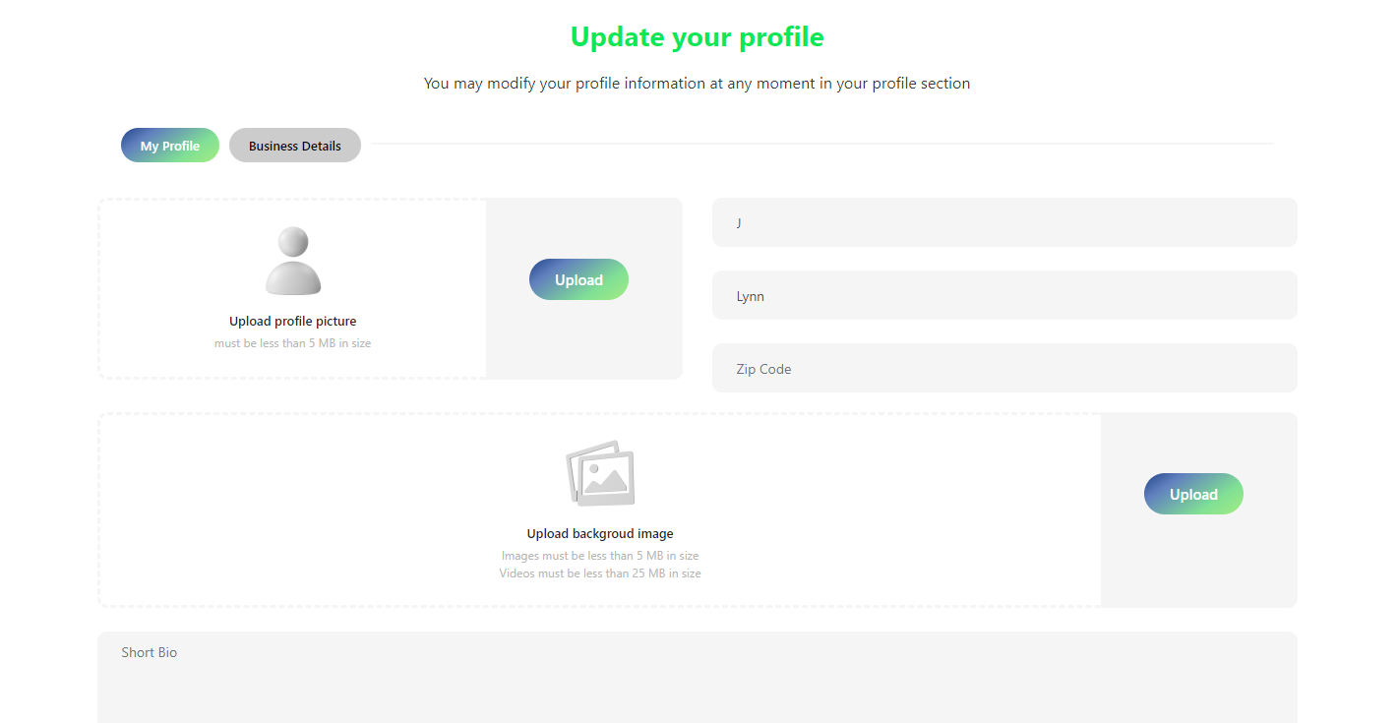

- Email Verification:
For those users, who is unable to verify himself/herself by clicking on the email verification link, admin can verify them by toggle on the “Email Verified” column.
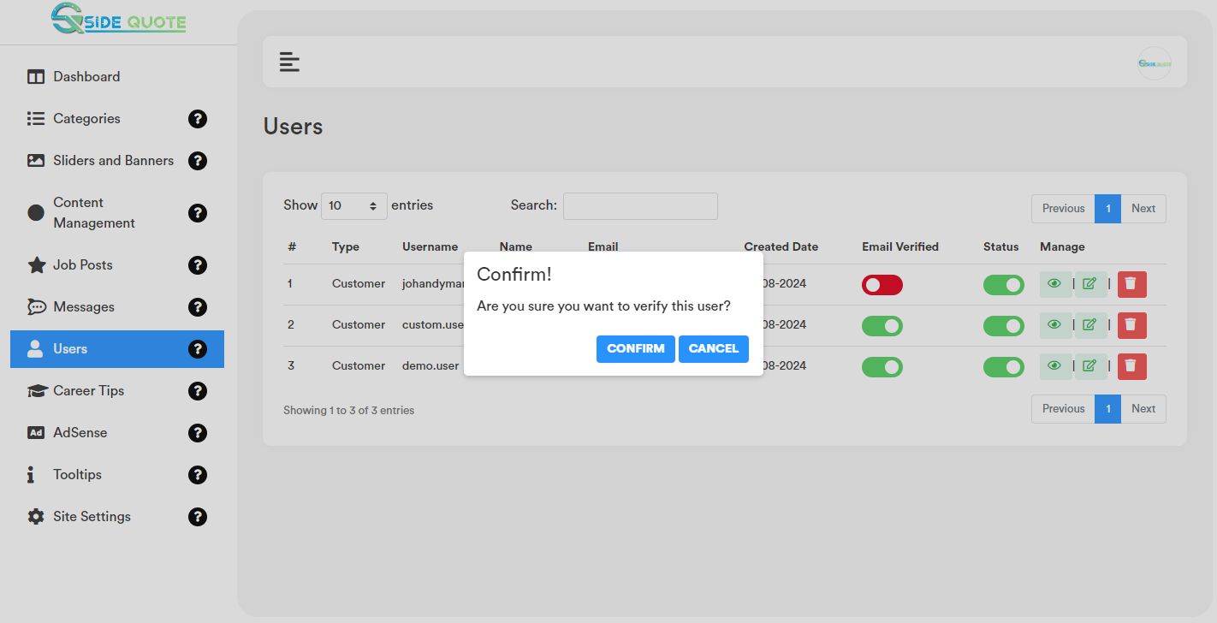

- Status (Active/Inactive):
Admin Can active and inactive user by toggle on the “Status” column.
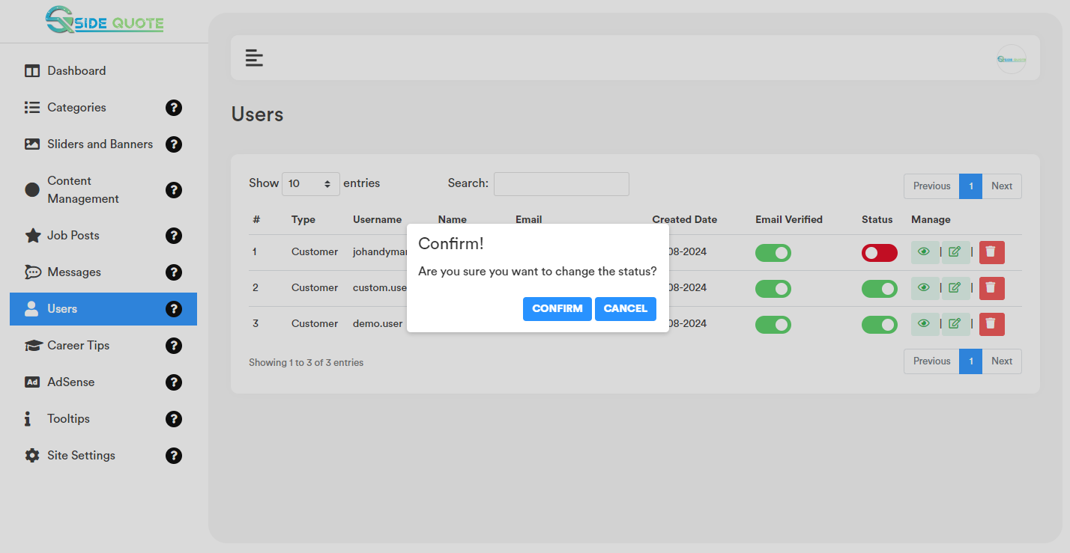

- Delete Record:
If user click on the “Delete” Button, admin will get a confirmation popup. Once confirm it will delete the related data.
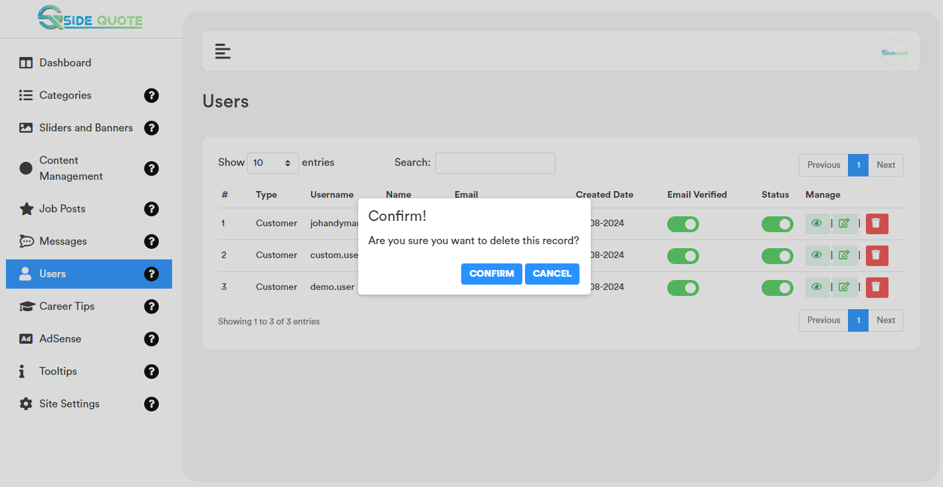

- User Search:
User can search any record by typing text on the search textbox.
- Career Tips:
All the uploaded data will be visible on the website homepage career tips section.
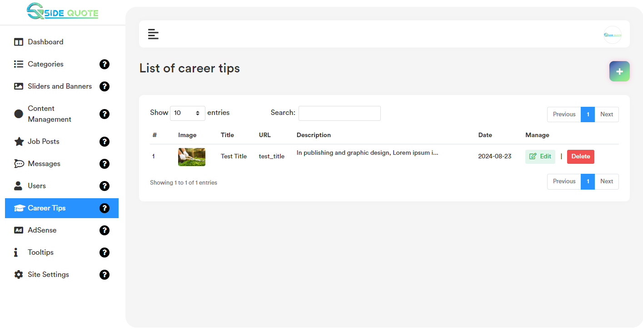

- Add Career Tips:
Career tips list page top right corner click on the “+” icon. User will get a form to add new career tips. Please check the below screenshot.
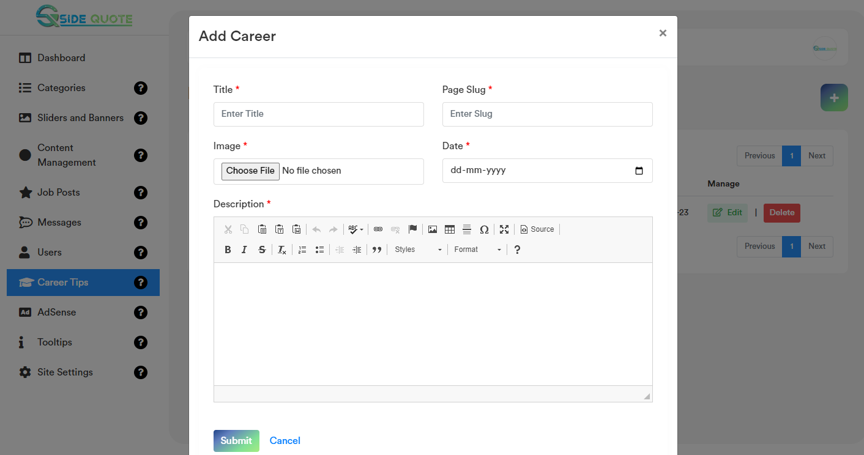

- Edit Career Tips:
Career tips list page for each record if user click on the “Edit” option, it will open a form containing the existing data for that particular record. After making the change click on the “Save Changes” button. It will update the existing record will the updated data. Please check the below screenshot.

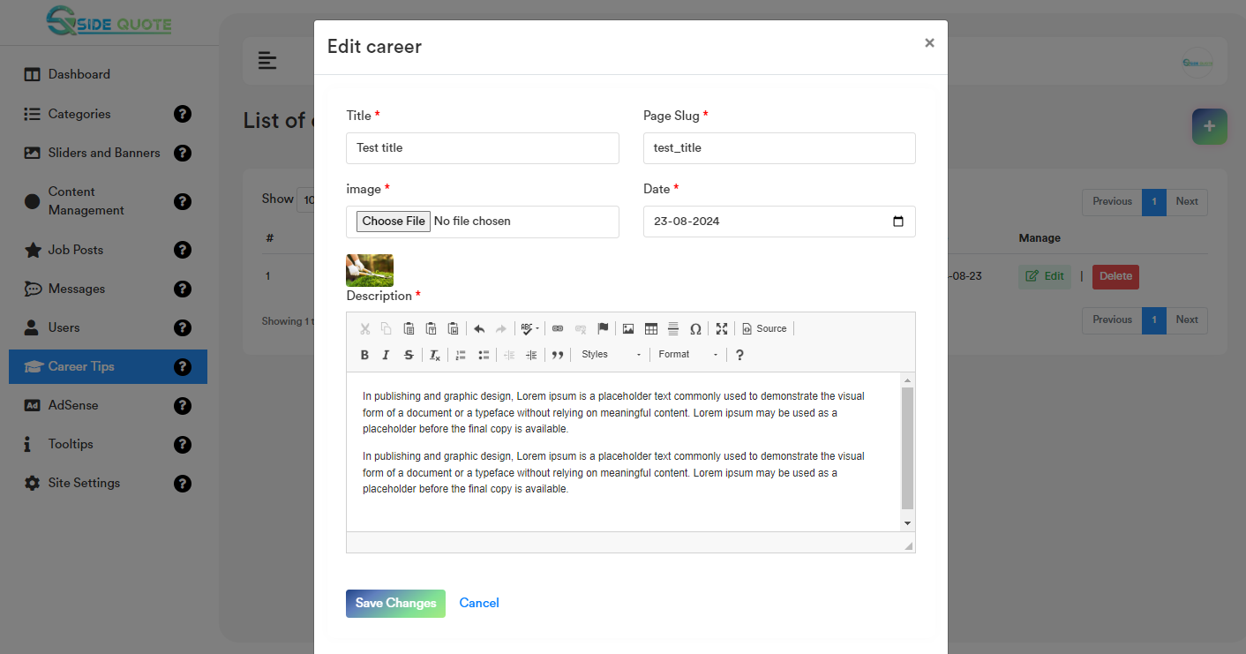

- Delete Career Tips:
If user click on the “Delete” Button, admin will get a confirmation popup. Once confirm it will delete the related data.

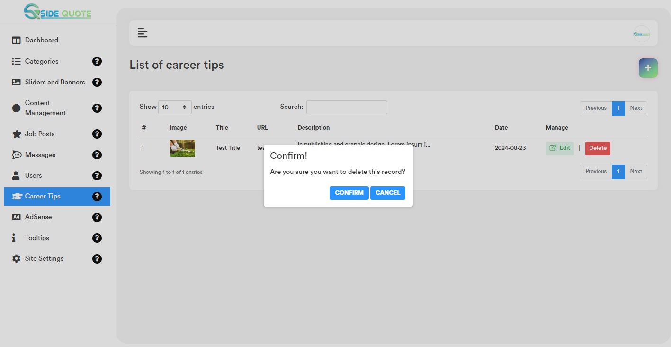

- Search Career Tips:
User can search any record by typing text on the search textbox.

- AdSense: All the uploaded data will be visible on the website homepage ad section
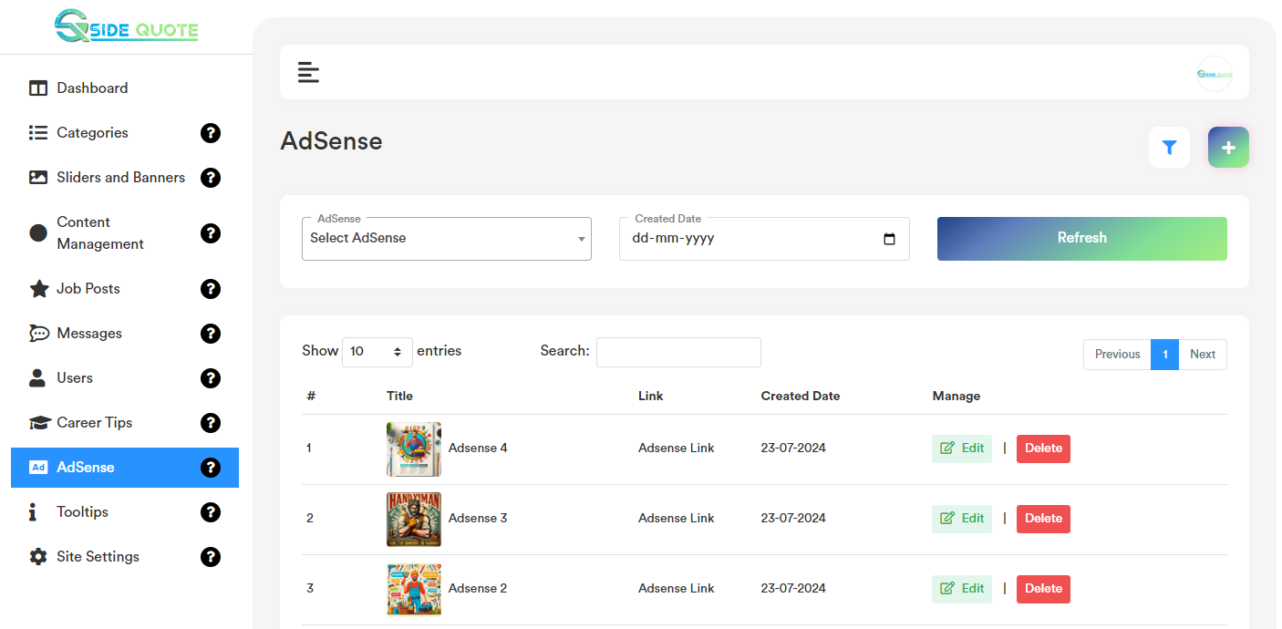

- Add Ad Sense:
Ad Sense list page top right corner click on the “+” icon. User will get a form to add new ad. Please check the below screenshot.

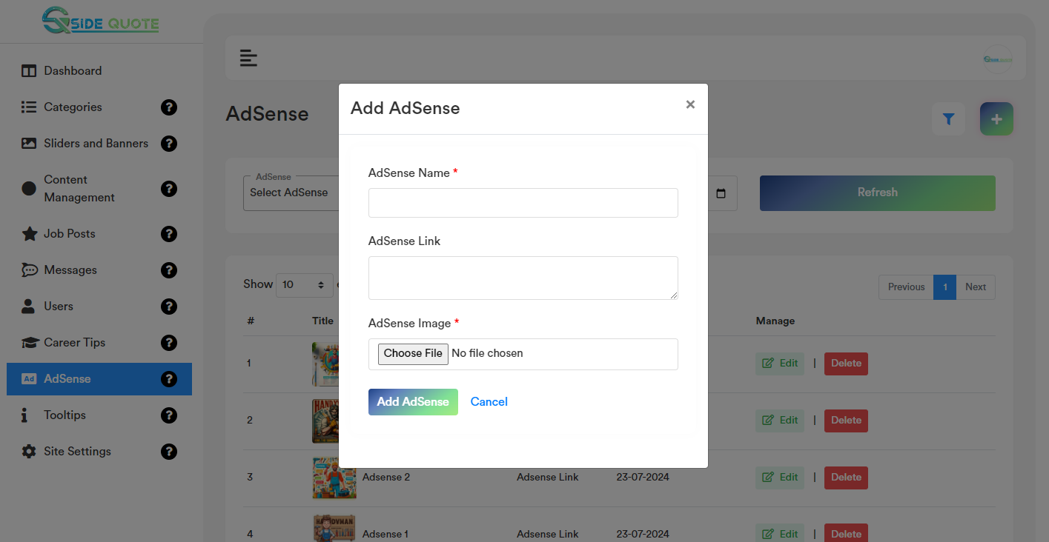

- Edit Ad Sense:
Ad Sense list page for each record if user click on the “Edit” option, it will open a form containing the existing data for that particular record. After making the change click on the “Save Changes” button. It will update the existing record will the updated data. Please check the below screenshot.

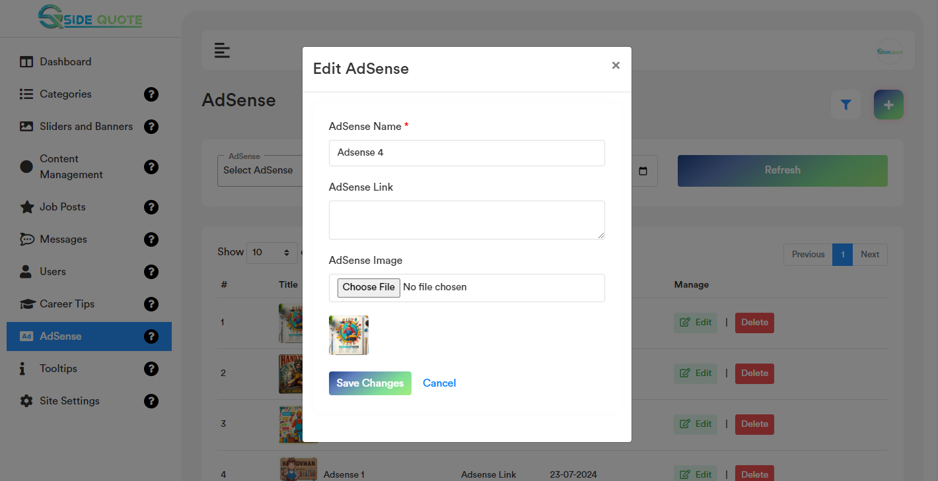

- Delete Ad Sense:
If user click on the “Delete” Button, admin will get a confirmation popup. Once confirm it will delete the related data.

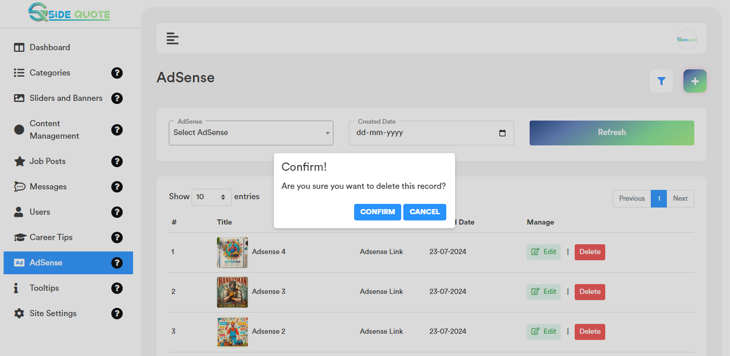

- Search Ad Sense:
User can search any record by typing text on the search textbox.

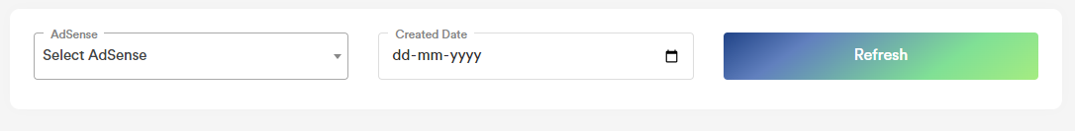

- Settings:

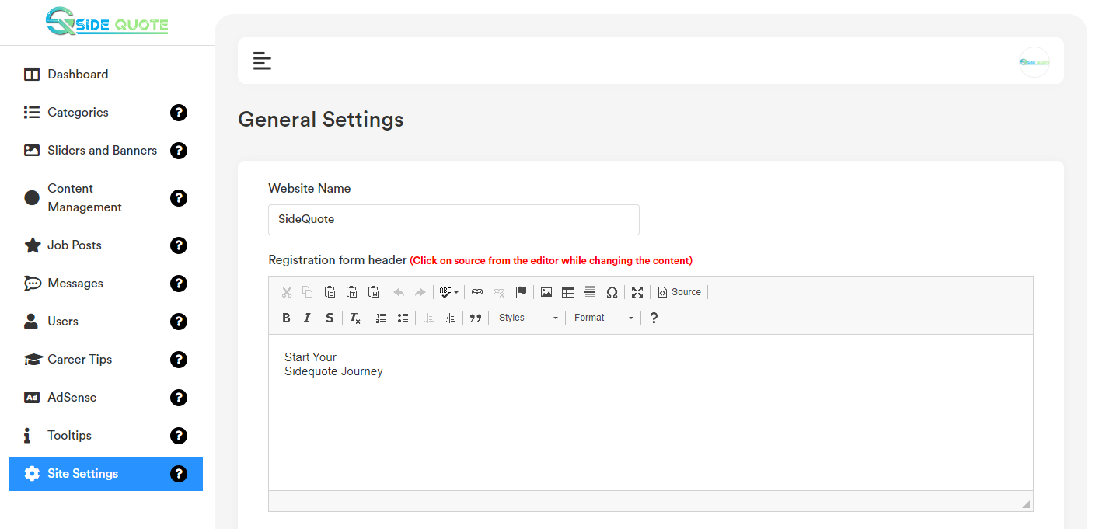
- Address:
Address data will be visible on the website footer and contact us page.
- Social Media Link: This data will be visible on the website footer.
- Header Logo: Header logo will be visible on the website header top menu section.
- Footer Logo: Footer logo will be visible on the website footer section.
- Favicon: Favicon will be visible on the top of the browser ison.

